ASSIGNMENT 6

180919

* Run & Understand the Login/Logout/Register app, including the hashed password, flask_login, sessions, web forms in Flask-Python

The purpose of the hash password field is to hold a hash of the user password, which will be used to verify the password entered by the user during the log in process. Flask_Login is an extension that manages the user logged-in state. It provides the "remember me" functionality that allows users to remain logged in even after closing the browser window. Web forms in this application uses the Flask_WTF extension. This extension uses Python classes to represent web forms. A form class simply defines the fields of the form as class variables.

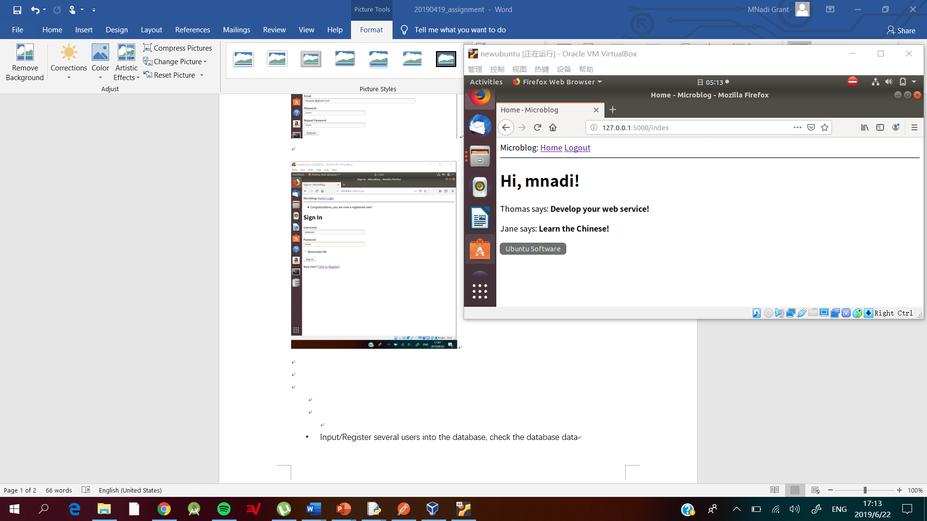

* Input/Register several users into the database, check the database data

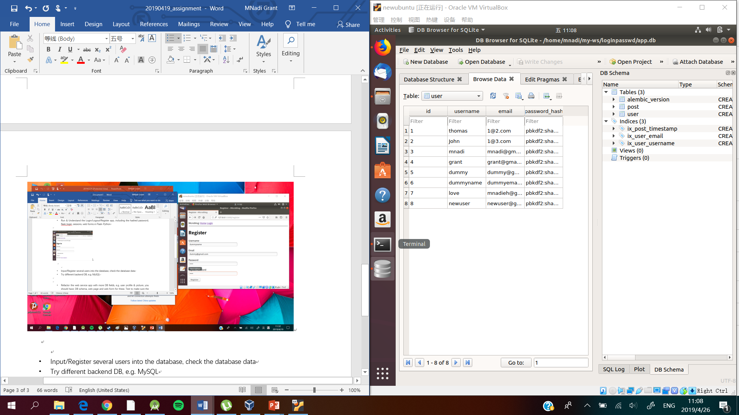

* Try different backend DB, e.g. MySQL
* Refactor the web service app with more DB fields, e.g. user profile & picture, you should have: DB schema, web page and web form for these. Test to make sure the requirement is met.

**User Profile added**

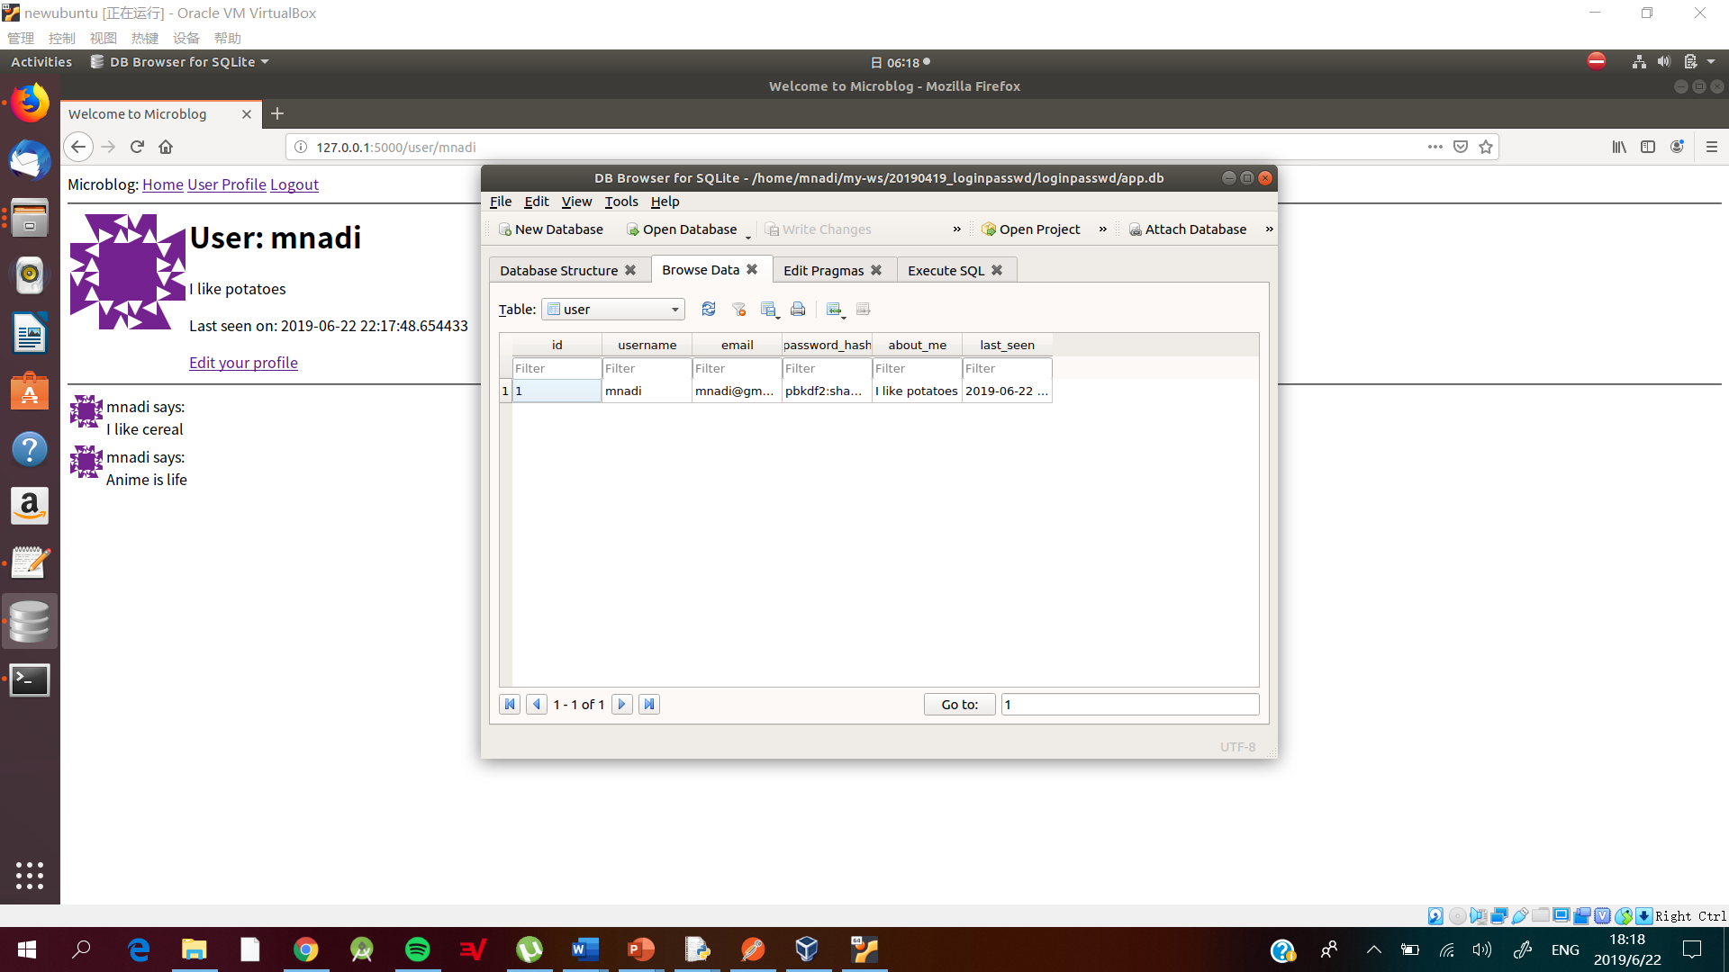

**Tests Conducted for profile picture and login function**

